**6.How to backup Raspberry Pi system**

1. You need a SD card and card reader，above Class4.

2. You need to use a tool to write the Raspberry Pi system image：Win32DiskImager.zip

(Note : This software in the Tools folder)

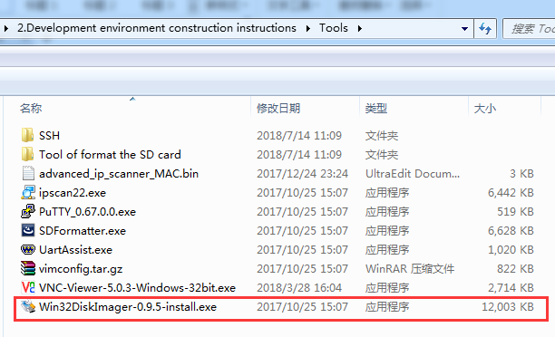

The installation method of this software is included in file (1.Download and write the Raspberry Pi system image)

You need to create a blank(xxx.img),and select SD card, click Read. As shown in the figure below.

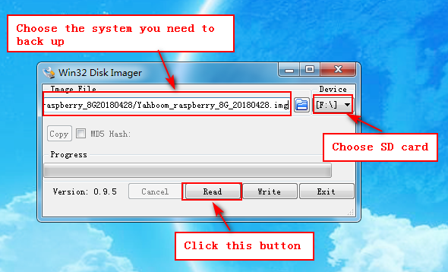

(Note:If you use this method, the space occupied by the file after backup is the space occupied by the SD card instead of the space occupied by the original system)